**Gradient Descent in Practice II - Learning Rate**

**Note:** [5:20 - the x -axis label in the right graph should be θ rather than No. of iterations ]

**Debugging gradient descent.** Make a plot with *number of iterations* on the x-axis. Now plot the cost function, J(θ) over the number of iterations of gradient descent. If J(θ) ever increases, then you probably need to decrease α.

**Automatic convergence test.** Declare convergence if J(θ) decreases by less than E in one iteration, where E is some small value such as 10−3. However in practice it's difficult to choose this threshold value.

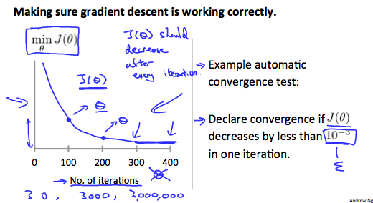

It has been proven that if learning rate α is sufficiently small, then J(θ) will decrease on every iteration.

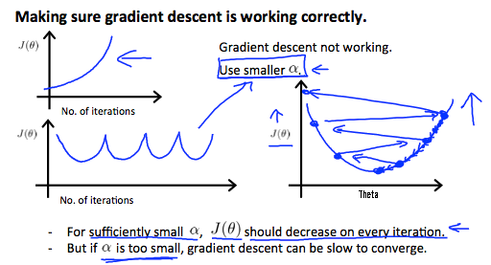

To summarize:

If α is too small: slow convergence.

If α is too large: ￼may not decrease on every iteration and thus may not converge.